Guidance for Topic 1 DQ 2
- First, make sure to enter your name in I12.

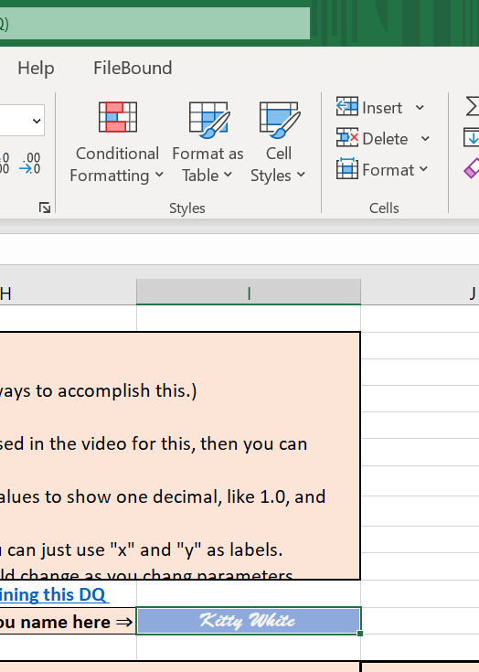

- Enter the given pair of points.
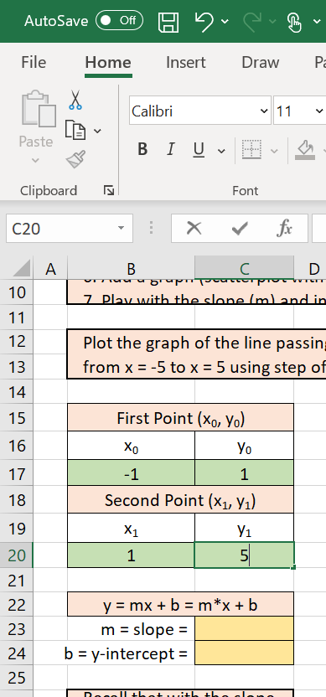

- For the slope, please see the formula circled in red.

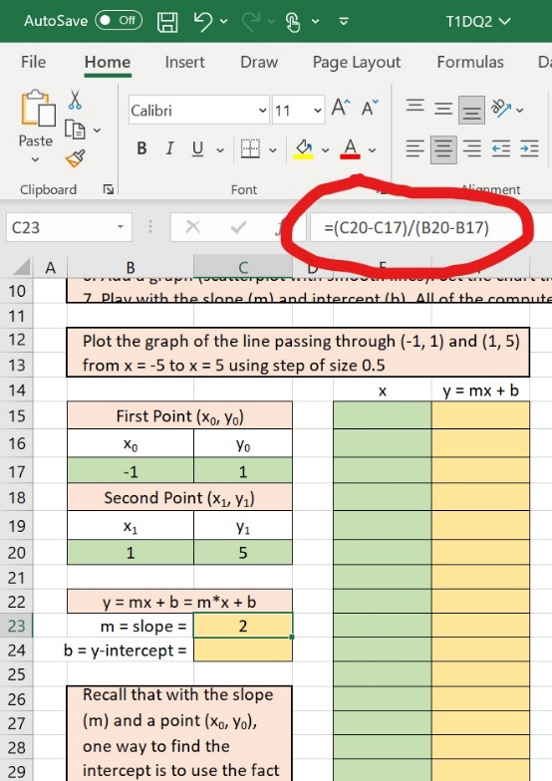

- For the intercept, please see the formula circled in red.

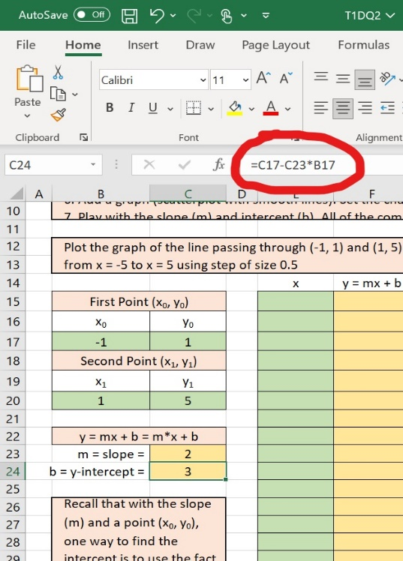

- To quickly fill out the values of x in column E, enter =E15+0.5 in E16 and drag down this formula in column E. This is the explanation given by Microsoft as to how to drag the formula: https://support.microsoft.com/en-us/office/fill-a-formula-down-into-adjacent-cells-041edfe2-05bc-40e6-b933-ef48c3f308c6

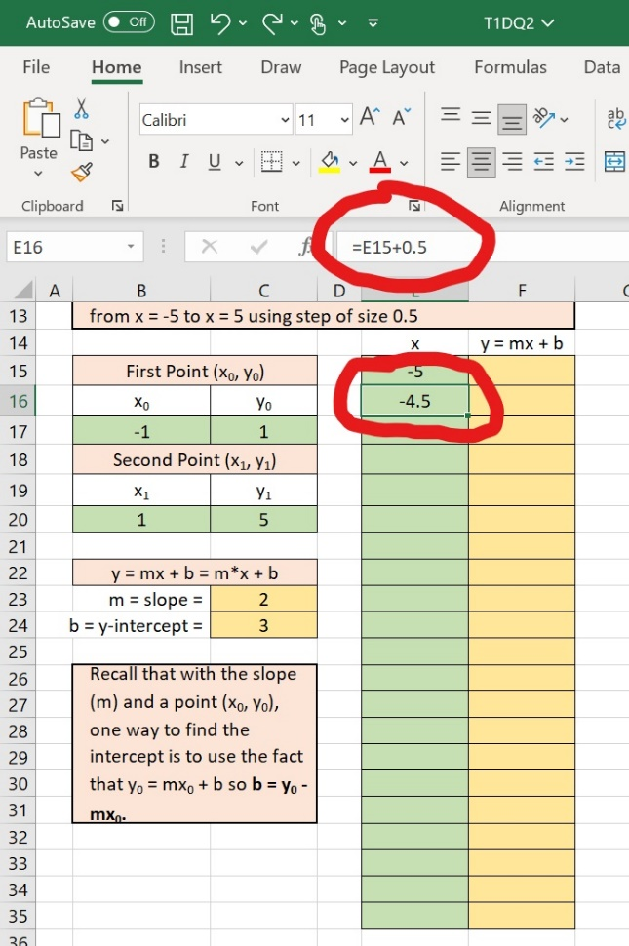

- Similarly, you need to fill out column F. Make sure to use $ for C23 and C24. $ fixes your choices of row/column. “Anchoring cells” is explained here:
https://www.extendoffice.com/documents/excel/3506-excel-anchoring-cells.html

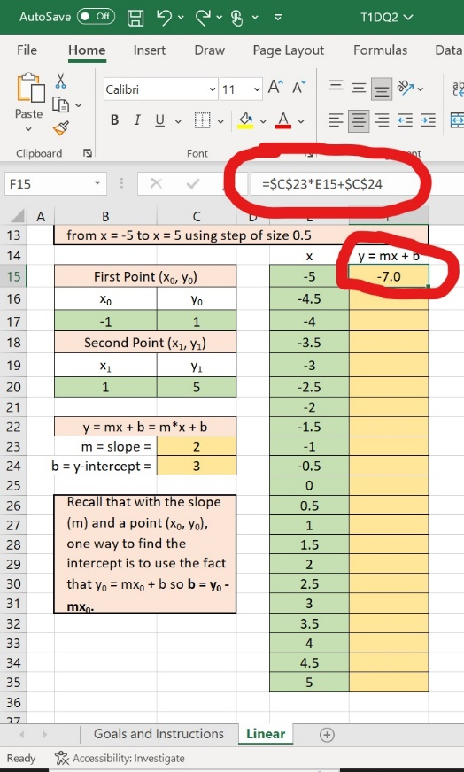

- Next, make sure to highlight from E14 to E35 and from F14 to F35 (i.e., including x and y=mx+b). Then, at the top, choose “Insert” and click “Recommended Charts.”

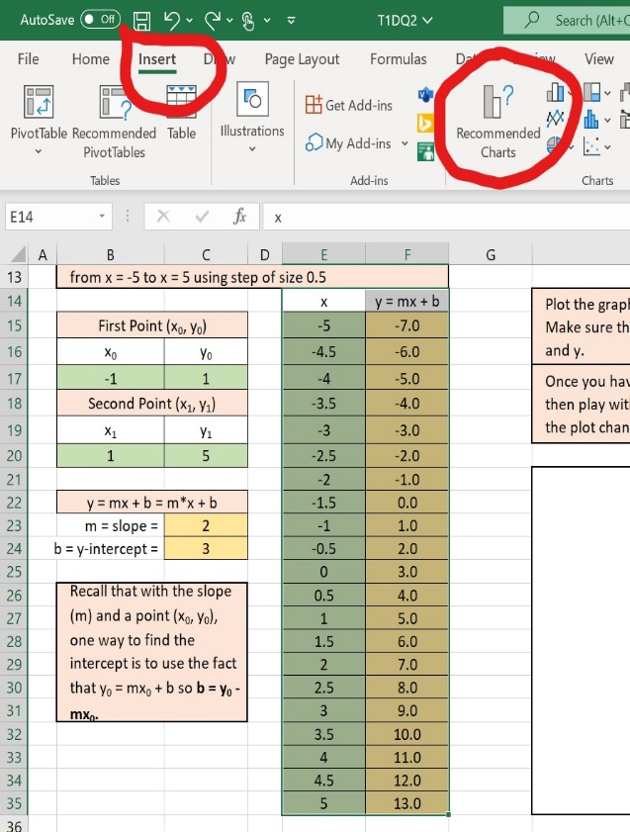

- Choose the top option.

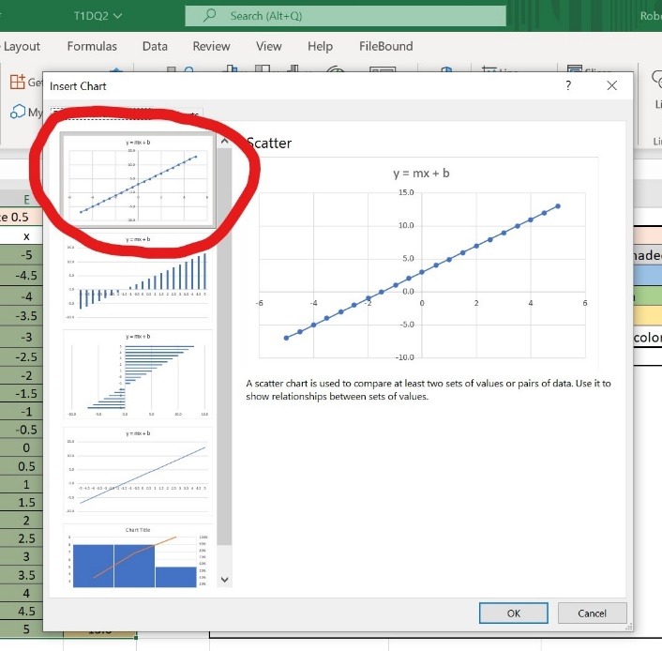

- Move your graph to the indicated box and click +. Then, you will find options to label the axes.

